**Practical-18☺**

Write a C program to generate and display a multiplication table based on user input:

***Code:***

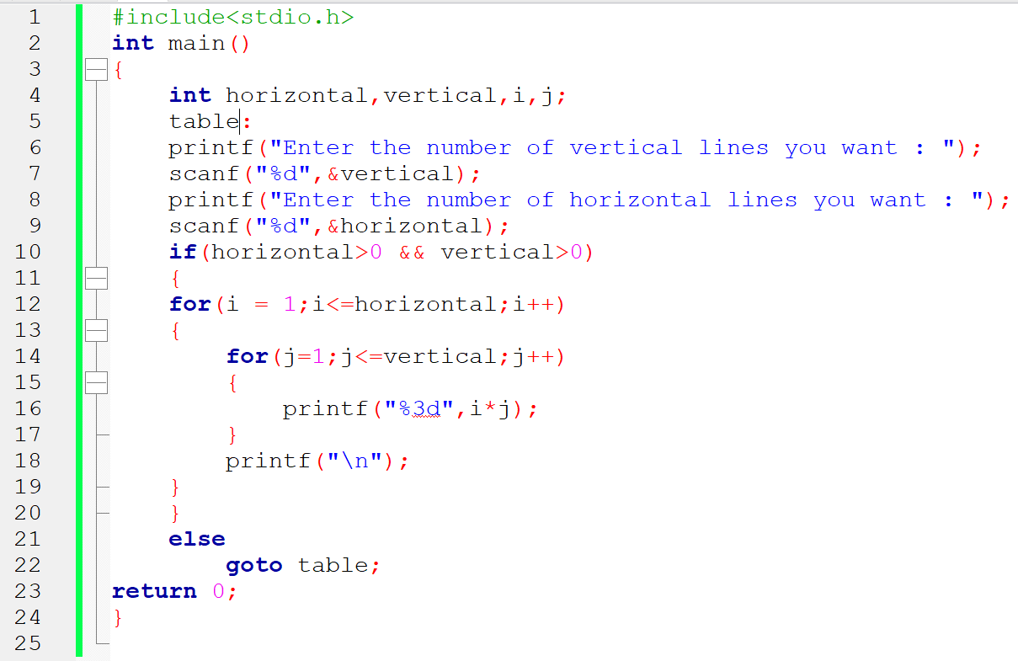

**Output:-**

